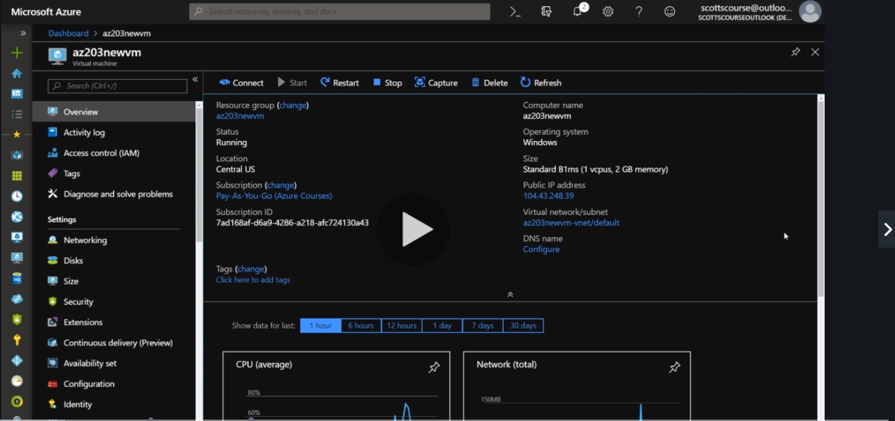

What is a virtual Machine.

Use RDP or SSH to access your virtual Machine.

In RDP you can change a VM to convert it into a server.

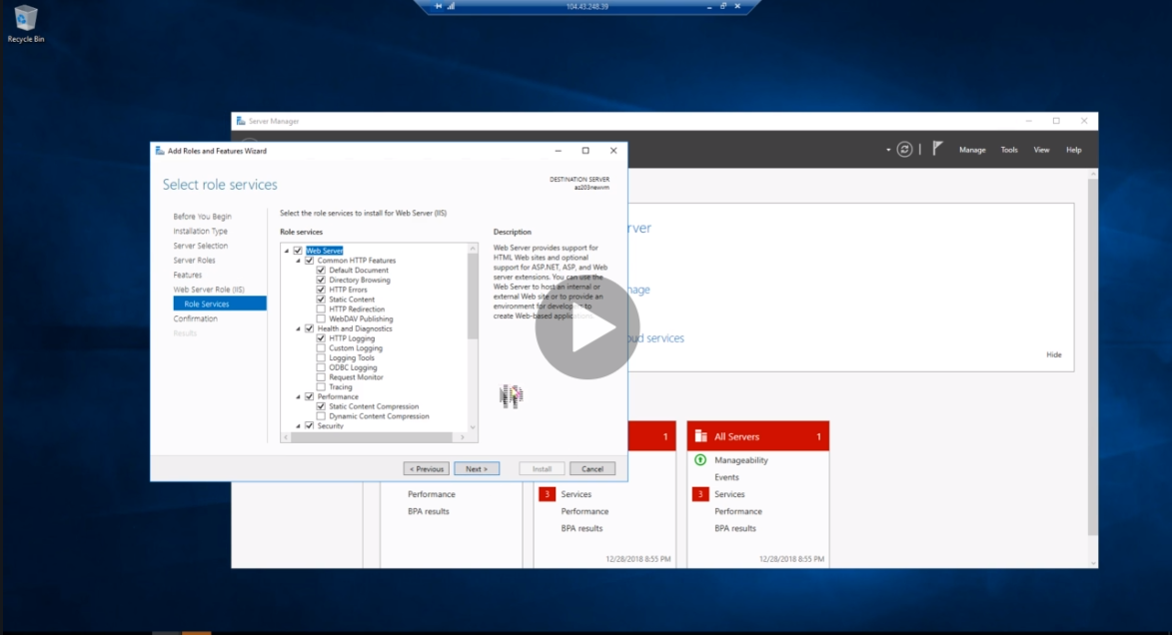

Virtual Machines estimates comes from their size, ram, storage, transactions 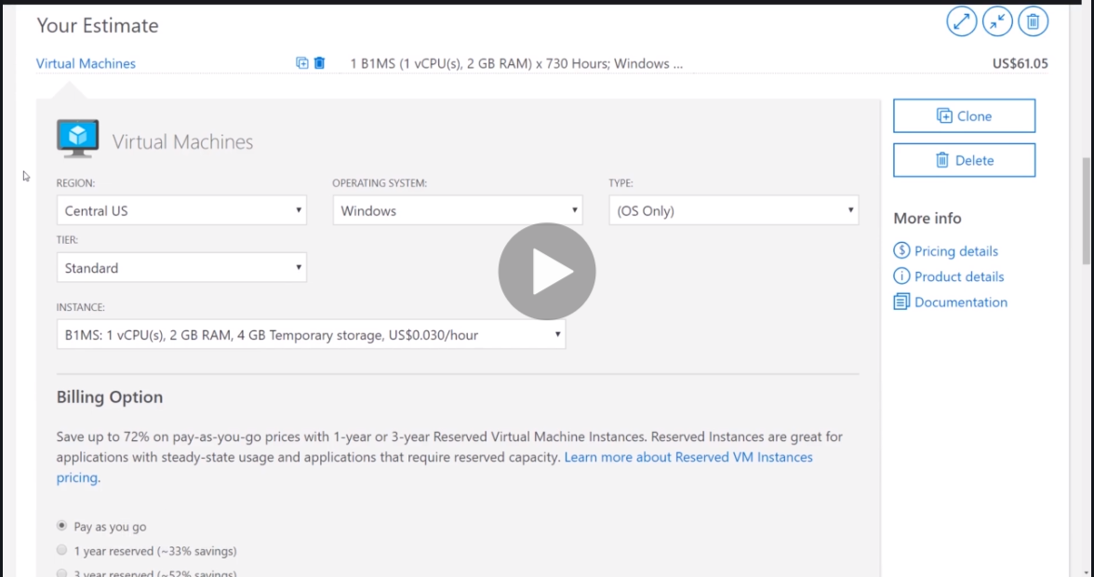

A Cheat sheet for Virtual Machines which Azure provide.

<https://mp4-c.udemycdn.com/2019-12-29_19-07-17-252b84ebd1707181145fef3c99d2e729/original.pdf?e=1586831786&h=8b32acc5efc8b6e72df3f2a45c7d78ec>